



Proudly Introduce



Contents

Introduction 3

The Presentation 3

This Hand-out 3

Technology in Education 4

Current Market Saturation 5

Demonstration - TeachEasy 6

Demonstration – LearnEasy 7

Product Pricing and Potential Market Distribution 8

Advertisement 10

Financial Projections 11

Projected Yearly Sales and Market Penetration Percentages 13

References 14

# Introduction

Welcome, and thank you for attending sofia’s introduction to the brand new interactive learning applications “TeachEasy” and “LearnEasy”. We hope to provide an insight into the exceptional performance and learning advantages these programs offer, whilst instilling confidence in our company’s sound ethics and quality assurance.

# The Presentation

* An Introduction to sofia – Our Aims and Goals
* The Advancement of Technology in Education
* The Current Market Saturation
* An Introduction and Demonstration of Our Brand New, Innovative Products, TeachEasy and LearnEasy
* Our Product Pricing and Potential Market Distribution
* Our Sales Strategy
* Financial Projections
* Our Considerations for Future Development

You will then be given the opportunity to ask any questions you may have about our product, and the chance to speak to any member of our diverse team regarding specific areas you may wish to know more about.

# This Hand-out

The remainder of this hand-out contains a more detailed breakdown, and close up views of the subjects discussed in this presentation. It is an opportunity for those more interested in certain aspects of sofia’s products and projections to consider our methods more closely.

# Technology in Education

**Percentile illustration of classrooms with access to technology**

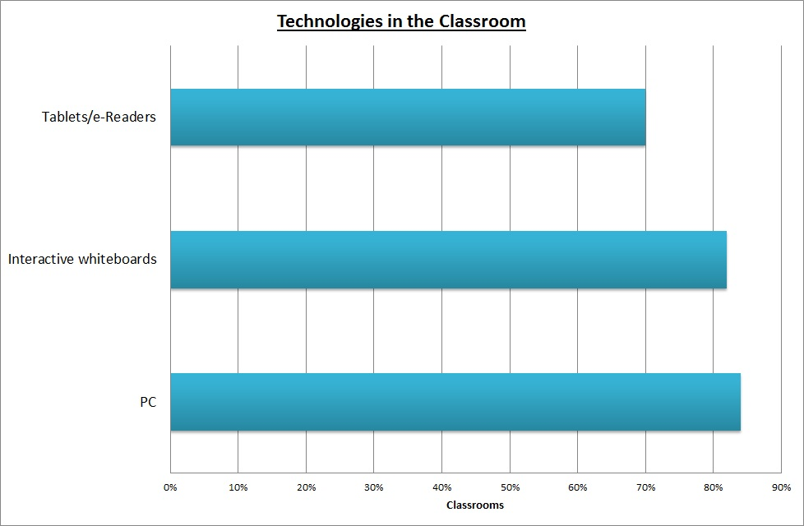

**Market reaction to currently available learning aids**

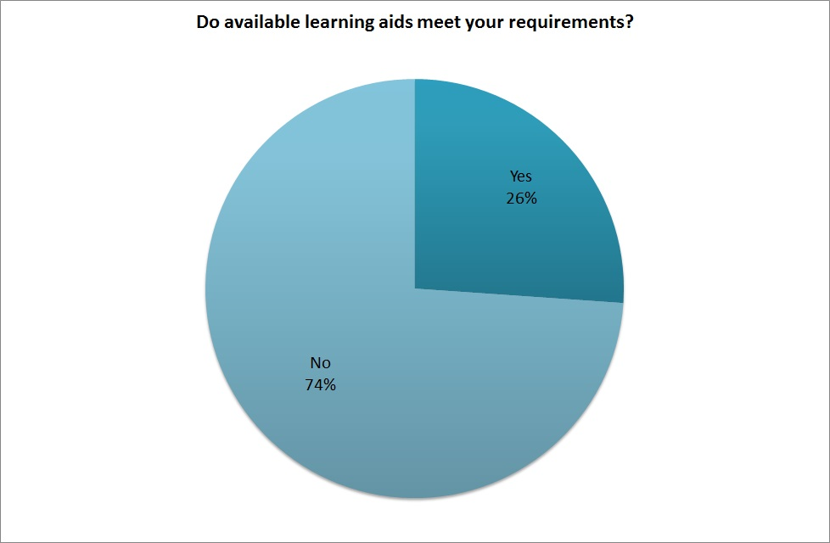

# Current Market Saturation

**Main Competitors**

* 
  + £6,900 per school per year for full syllabus content
  + All content Provided
  + Interactive participation
  + Currently used in 31% of schools
* 
  + £265 / £565 per school per year dependant on syllabus level
  + Maths content provided
  + Interactive participation
  + Currently used in 60% of secondary schools
* [](http://www.google.co.uk/url?sa=i&rct=j&q=&esrc=s&frm=1&source=images&cd=&cad=rja&uact=8&ved=0CAcQjRw&url=http://ponunaticentuaula.blogspot.com/2010/06/crear-examenes-online-wiziq.html&ei=CMFoVZL0FsWwUYqHgfAI&bvm=bv.94455598,d.d24&psig=AFQjCNFPKH5jArBvYNMzxGi8TXonhFGV1w&ust=1433014914863728)
  + £652.92 per academic per year for 25 students
  + Variable price dependant on number of users
  + No Content Provided
  + Interactive elements can be supplied by academic online
* 
  + £109 one off price for 5 licences
  + No content provided – user end customization
  + No interactive elements
  + Used by 6 million teachers worldwide every day

# Demonstration - TeachEasy

**TeachEasy**

1

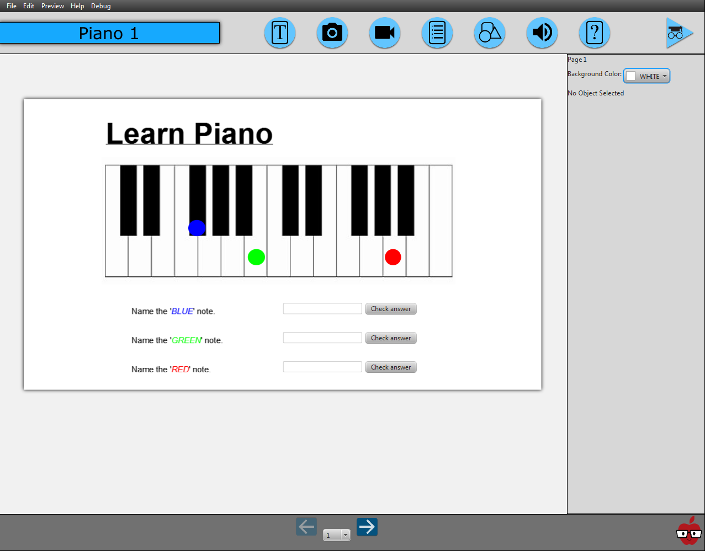

12

11

10

13

81

51

61

71

21

9

31

41

1. Menu system
2. Insert text object
3. Insert image
4. Insert video
5. Insert multiple choice question
6. Insert graphic
7. Insert audio clip
8. Insert answer box
9. Manage lesson settings
10. Object preference / settings pane
11. Page preview
12. Select page
13. Preview lesson

# Demonstration – LearnEasy

**LearnEasy**

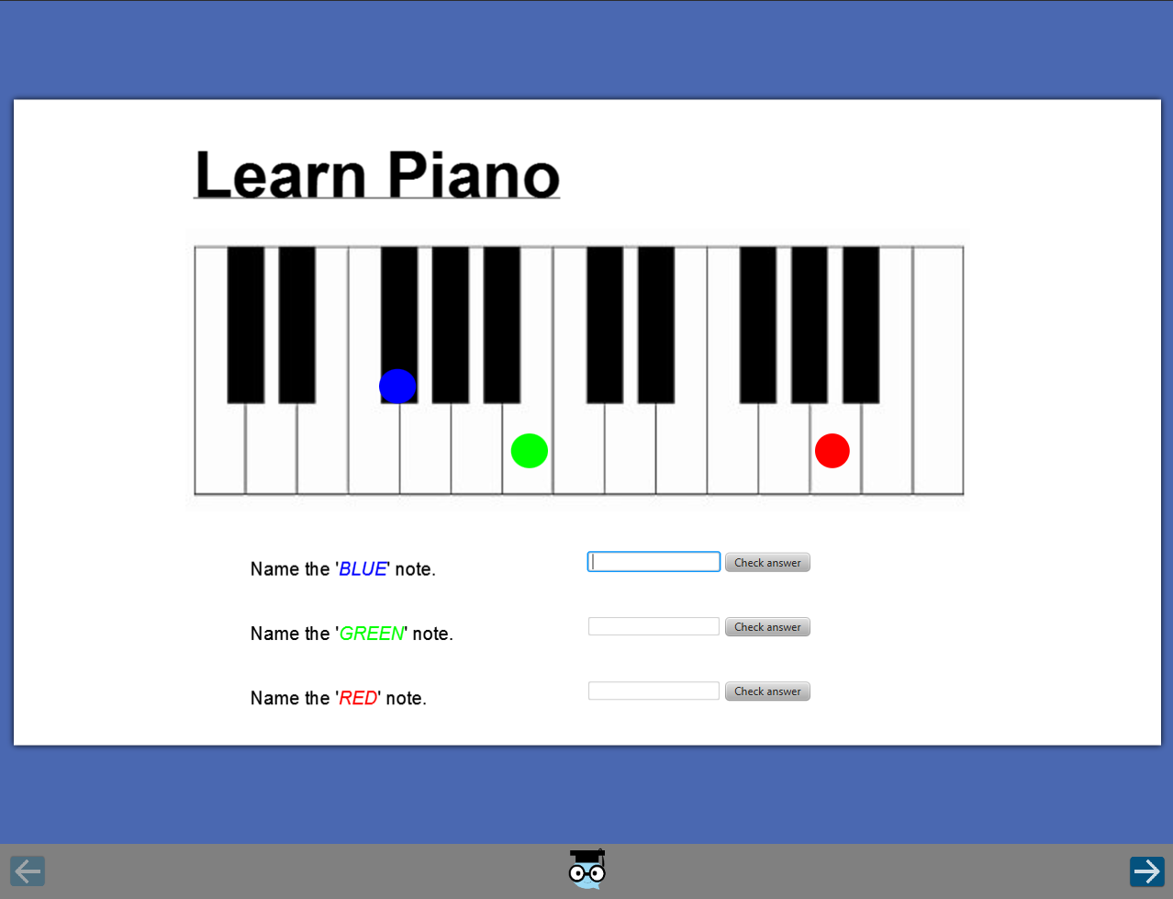

2

3

1

1. Lesson
2. Next page
3. Previous Page

# Product Pricing and Potential Market Distribution

**TeachEasy**

£29.99 per single TeachEasy licence

10% Discount for bulk orders (20+)

Averages to £569.81 per school (Assumes 19 teachers per school) [1]

**LearnEasy**

Free – Unlimited student users

**Quantitative Potential Market Distribution**

|  |  |
| --- | --- |
| Potential Market | Number |
| Primary Teachers | 213,500 |
| Secondary Teachers | 209,900 |
| Special Teachers | 20,300 |
| Centrally Employed Teachers | 7,400 |
| Tutors | 60,371 |
| Total Teachers | 451,100 |
| Total | 511,471 |

**Quantitative Likely Market Distribution Based on Survey Results**

|  |  |  |
| --- | --- | --- |
| Likely Market | % Market Interested | Number Interested |
| Primary Teachers | 100.00% | 213,500 |
| Secondary Teachers | 66.67% | 139,940 |
| Special Teachers | N/A | 0 |
| Centrally Employed Teachers | N/A | 0 |
| Tutors | 61.54% | 37,152 |
| Total Teachers | 78.35% | 353,440 |
| Total | 76.37% | 390,593 |

# Advertisement

**TES - £18, 091.80**

Quarter page magazine advertisement every 2 months (**6** adverts per year)  
Advertisement aimed at teachers and schools

**378,000** UK readers [2]

Assume **16.67%** (1 in 6) will see each advert   
(advert will make a single impression on each reader per year)

Assume **81.41%** like and approve of product (from survey)

Assume **1%** will trial and purchase the product

Assume a **5% increase** in sales through word of mouth

Expected sales per year from advertisement:

**AdWords – Up to £3, 650**

Advertised Google search result with automatically adjusted PPC (Pay per Click) bid amount  
Advertisement aimed at tutors

Assume 16 clicks per day / 6000 impressions [3]

Equates to **5840** clicks per year

Assume **1%** of customers clicking on the advert will trial and purchase product

Assume **50% increase** in sales through word of mouth

Expected sales per year from advertisement

# Financial Projections

**Assumptions**

No fixed future development costs

50% renewal rate

Sales figures as predicted by marketing (Teachers: 3231, Tutors: 88 per Year)

Continue with current labour hours

Static long term “new customer” base growth

**Year 1: Net Profit and Sales Revenue by Month**

**Year 1-5: Net Profit and Sales Revenue by Year**

**Net Profit Projections**

Year 1: - £16, 077.33

Year 3: £43, 062.22

Year 5: £63, 274.85

**Loan Repayment Projections**

End of Year 2 – (Jul 2016 – Jul 2017): £15, 000

End of Year 3 – (Jul 2017 – Jul 2018): £40, 000

End of Year 4 – (Jul 2018 – Jul 2019): £10, 000

Total: £65, 000

# Projected Yearly Sales and Market Penetration Percentages

**Note:** “Market” is defined as our total market whereas “Likely market” is defined as our predicted market skewed from the total market as a result of our product interest survey.

|  |  |  |  |  |  |  |  |  |  |  |  |  |  |  |  |
| --- | --- | --- | --- | --- | --- | --- | --- | --- | --- | --- | --- | --- | --- | --- | --- |
| Number of sales | Year 1 | | | Year 2 | | | Year 3 | | | Year 4 | | | Year 5 | | |
| Return | New | Total | Return | New | Total | Return | New | Total | Return | New | Total | Return | New | Total |
| Teachers | 0 | 3,231 | 3,231 | 1,616 | 3,231 | 4,847 | 2,423 | 3,231 | 5,654 | 2,827 | 3,231 | 6,058 | 3,029 | 3,231 | 6260 |
| Tutors | 0 | 88 | 88 | 44 | 88 | 132 | 66 | 88 | 154 | 77 | 88 | 165 | 83 | 88 | 171 |
| Total Sales | 0 | 3,319 | 3,319 | 1,660 | 3,319 | 4,979 | 2,489 | 3,319 | 5,808 | 2,904 | 3,319 | 6,223 | 3,112 | 3,319 | 6,431 |
| Total Sales income (£) | £0 | £89,844 | £89,844 | £44,922 | £89,844 | £134,766 | £67,383 | £89,844 | £157,227 | £78,613 | £89,844 | £168,457 | £84,229 | £89,844 | £174,072 |

|  |  |  |  |  |  |  |  |  |  |  |  |  |  |  |  |
| --- | --- | --- | --- | --- | --- | --- | --- | --- | --- | --- | --- | --- | --- | --- | --- |
| Market Penetration | Year 1 | | | Year 2 | | | Year 3 | | | Year 4 | | | Year 5 | | |
| Return | New | Total | Return | New | Total | Return | New | Total | Return | New | Total | Return | New | Total |
| Teachers | 0.00% | 0.72% | 0.72% | 0.36% | 0.72% | 1.07% | 0.54% | 0.72% | 1.25% | 0.63% | 0.72% | 1.34% | 0.67% | 0.72% | 1.39% |
| Tutors | 0.00% | 0.15% | 0.15% | 0.07% | 0.15% | 0.22% | 0.11% | 0.15% | 0.26% | 0.13% | 0.15% | 0.27% | 0.14% | 0.15% | 0.28% |
| Total | 0.00% | 0.65% | 0.65% | 0.32% | 0.65% | 0.97% | 0.49% | 0.65% | 1.14% | 0.57% | 0.65% | 1.22% | 0.61% | 0.65% | 1.26% |

|  |  |  |  |  |  |  |  |  |  |  |  |  |  |  |  |
| --- | --- | --- | --- | --- | --- | --- | --- | --- | --- | --- | --- | --- | --- | --- | --- |
| Likely Market Penetration | Year 1 | | | Year 2 | | | Year 3 | | | Year 4 | | | Year 5 | | |
| Return | New | Total | Return | New | Total | Return | New | Total | Return | New | Total | Return | New | Total |
| Teachers | 0.00% | 0.88% | 0.88% | 0.44% | 0.88% | 1.32% | 0.66% | 0.88% | 1.54% | 0.77% | 0.88% | 1.65% | 0.86% | 0.91% | 1.77% |
| Tutors | 0.00% | 0.24% | 0.24% | 0.12% | 0.24% | 0.36% | 0.18% | 0.24% | 0.41% | 0.21% | 0.24% | 0.44% | 0.22% | 0.24% | 0.46% |
| Total | 0.00% | 0.82% | 0.82% | 0.41% | 0.82% | 1.23% | 0.62% | 0.82% | 1.44% | 0.72% | 0.82% | 1.54% | 0.80% | 0.85% | 1.65% |

# References

**[1]** GOV.UK. "Number of schools, teachers and students in England,". [Online]. Available: https://www.gov.uk/government/publications/number-of-schools-teachers-and-students-in-england/number-of-schools-teachers-and-students-in-england [Accessed: May. 24, 2015].

Number of UK Teachers (Excluding Nurseries): 451,100

Number of UK Schools (Excluding Nurseries): 23,948

Average number of teachers per school:

**[2]** TES. “TES in print, online and in person.”. [Online]. Available: <https://www.tes.co.uk/article.aspx?storyCode=6000212> [Accessed: May. 30, 2015]

**[3]** Google. “Google AdWords”. [Online]. Available: <https://www.google.co.uk/adwords/> [Accessed: May. 30, 2015]